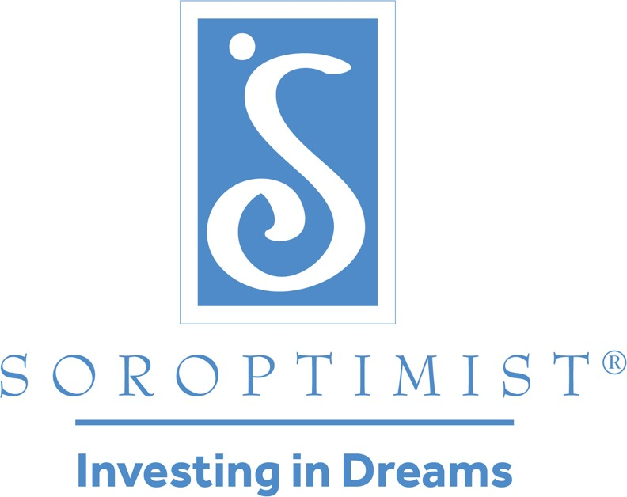

Soroptimist is a global volunteer organization that provides women and girls with access to the education and training they need to achieve economic empowerment.

**SOROPTIMIST INTERNATIONAL OF THE AMERICAS, INC.®**

Greetings Soroptimists!

What a pleasure it is to welcome you all to your spring conference on behalf of the SIA Board of Directors and staff.

Around our federation the regions are coming together to celebrate achievements and connect with members from around their regions. This is always a special time of year and I know that we have so much to be thankful for as we gather. I always am excited about the opportunity to participate in the fun and informative activities that bring our membership closer together and to discover new opportunities to help women and girls.

You know, each and every day, Soroptimists like you and I work to help women and girls pursue their economic goals and reach their personal best. Because I deeply believe in our mission, I am committed to doing everything I can to support our Big Goal of investing in half a million women and girls through access to education by 2031. To me, the possibilities for helping seem endless. And that's so exciting!

Remember the first region conference you attended? Or maybe this one is your first! I was in awe of the speakers, the workshops, the official visitors, and hearing about the amazing projects that the clubs were doing. Not much has changed for me—I’m still in awe of the important work we have the privilege of doing. The work that allows us to make life-long friends. The work that creates opportunities for own personal growth and development. The work that allows us to help women and girls DREAM BIG!

I passionately believe that empowered women empower women. And, because of our unity and strength, I believe we are helping build a future in which there are no limits on women's and girls' dreams—and that's just one of many reasons I'm proud to be a Soroptimist. Together, we will make a difference and help the dreams of more women and girls come true.

Before I close, I'd like to thank each of you for attending your region conference. You have the vision, the knowledge and the experience to help us pave our way into the future. Throughout this conference, please stay engaged, keep us proactive and help us shape the future of Soroptimist.

Dreaming Big Together,

Stephanie Smith

2022-2023 SIA President

1709 Spruce Street | Philadelphia, PA 19103 | 215-893-9000 | siahq@soroptimist.org | Soroptimist.org | LiveYourDream.org  
© Soroptimist International of the Americas, Inc.®