Improving the lives of women and girls
through programs leading to social
and economic empowerment.

Soroptimist International of the Americas

Baby Boomers: Generational Profile

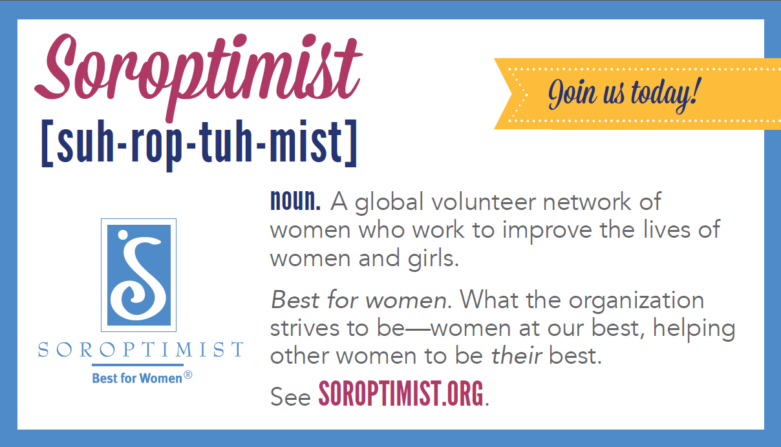
Born: 1946-1964
Age range in 2017: 53-71
General outlook: Optimistic

Baby Boomers are the post-World War II babies and are also known as the generation that “questioned authority” in many cultures. Boomers enjoyed unprecedented employment and educational opportunities in most countries and are generally optimistic.

Boomers value creativity—while their parents were conformists, this generation searched to break the mold. They love adventure and are risk-takers. Boomers tend to evaluate achievement in terms of personal fulfillment. This is the first generation to discover that lifetime employment no longer exists—so job security is not everything to them—but job satisfaction does matter.

With women now firmly implanted in the workforce, Boomers have been forced to re-evaluate the role of work in their personal lives. Boomers were the first generation to divorce at a higher rate than the two previous generations. Because Boomers invented new forms of families, they also incurred new stresses.

This generation shaped the 1960s and 1970s throughout the world. Boomers enjoyed unprecedented employment and educational opportunities in most countries, reaping the benefits of the previous generation’s financial restraint. A surge in college education enabled this generation to be the most influential of its time.

As Baby Boomers retire or start to near retirement, they have the desire, financial means, and time to participate in volunteer activities. Volunteering for Boomers is a way to spend their time doing what they want and when they want. It’s a chance to utilize and apply their skills while also giving in to interests they may not have had the time to pursue previously. They are open to trying and learning new things, so they won’t be hesitant to look for opportunities that veer away from what they’ve done professionally. Most importantly, they want to see the difference they are making—this is the generation bent on changing the world.

Baby Boomer Characteristics

Values
- Individual choice
- Community involvement
- Prosperity
- Ownership
- Self-actualizing
- Health and wellness

Attributes
- Adaptive
- Goal-oriented
- Focus on individual choices and freedom
- Adaptive to a diverse workplace
- Positive attitude

Work styles
- Confidence in tasks
- Emphasize team-building
- Seek collaborative, group decision making
- Avoid conflict

Sources and references:

Ken Culp, K. (April 2009). Recruiting and Engaging Baby Boomer Volunteers. Journal of Extension. Retrieved from URL.

Foster-Bey, J., Grimm, Jr.. R., & Dietz, N. (March 2007). Keeping Baby Boomers Volunteering: A Research Brief on Volunteer Retention and Turnover. Corporation for National & Community Service.

Baby Boomers. (n.d). Retrieved from http://www.valueoptions.com/spotlight_YIW/baby_boomers.htm.

