Improving the lives of women and girls
through programs leading to social
and economic empowerment.

Soroptimist International of the Americas

Baby Boomers: Notable Events That Shaped Their Perspectives

1946 Women are permitted to attend Tokyo Imperial University for the first time.
1948 Cambridge University begins granting degrees to women; The Universal Declaration of Human Rights, shaped largely by Eleanor Roosevelt, passes the UN General Assembly.
1949 First non-stop flight around the world; NATO established.
1951 Color TV introduced; Truman signs peace treaty with Japan, officially ending WWII.
1952 Car seat belts introduced; Polio vaccine created; UN General Assembly adopts the first international legal statement dealing with women’s rights at the Convention on the Political Rights of Women in New York City, NY; Chifuren, a Japanese women’s organization for civil rights and consumer affairs, is founded in Shigeri Yamataka.
1953 Vijaya Laskmi Pandit is the first female and first Indian president of the UN.
1954 Report says cigarettes cause cancer; Segregation ruled illegal in U.S.
1955 Disneyland opens; Ray Kroc opens his first McDonald's; Rosa Parks refuses to give up her seat on a bus.
1956 Elvis gyrates on Ed Sullivan's Show; Grace Kelly marries Prince Rainier III of Monaco; TV remote control invented.
1956 Autherine Junita Lucy enters racially segregated University of Alabama but is suspended for “her own safety” after three days.
1957 Dr. Seuss publishes The Cat in the Hat; Soviet satellite Sputnik launches space age.
1958 Venezuelan women protest government restrictions and are attacked by machete-wielding police (General Marcos Perez Jimenez is overthrown six days later); Peace symbol created.
1960 Mme. M. Nakayama becomes the first woman Japanese Cabinet member; Brazil's capital moves to brand new city—Brasília; First televised presidential debates; Most powerful earthquake ever recorded hits Chile; The birth control pill is approved by the FDA.
1961 Eleanor Roosevelt is appointed to chair the Commission on the Status Women; Bay of Pigs invasion; Berlin Wall built; Peace Corps founded.
1962 Andy Warhol exhibits his Campbell's Soup Can; Cuban missile crisis; First James Bond movie; First person killed trying to cross the Berlin Wall; First Wal-Mart opens.
1963 Betty Friedan publishes The Feminine Mystique; Soviet Cosmonaut Valentina Tereshkova is the first woman in space; U.S. President John F. Kennedy assassinated; Martin Luther King Jr. makes his "I Have a Dream" speech.
1964 Beatles become popular in the U.S.; Civil Rights Act passes in U.S.; Hasbro launches GI Joe action figure; Japan's first bullet train line opens.
1965 U.S. sends troops to Vietnam.
1966 National Organization for Women (NOW) founded; Indira Gandi becomes prime minister of India.
1967 Che Guevara killed; First heart transplant; Thurgood Marshall becomes the first African-American U.S. Supreme Court Justice.
1968 Japan's 300 million yen robbery; Martin Luther King Jr. assassinated; My Lai massacre; Robert F. Kennedy assassinated.
1969 ARPANET, the precursor of the internet, is created; Neil Armstrong becomes the first man on the moon; Rock-and-roll concert at Woodstock; Sesame Street first airs; Golda Meir becomes the first female prime minister of Israel.

Sources and references:
Rosenberg, J. (n.d). Timeline of the 20th Century. Retrieved from http://history1900s.about.com/od/timelines/tp/1940timeline.htm; http://history1900s.about.com/od/timelines/tp/1950timeline.htm; & http://history1900s.about.com/od/timelines/tp/1960timeline.htm
Friedman, D., Mangiafico, L., Blake, J. Wintz, L. (1996). Soroptimist International of the Americas: Serving Communities for 75 Years. Soroptimist International of the Americas

Baby Boomers: Notable Soroptimist Events

1947 The first Soroptimist club outside of the U.S. and Canada is chartered in Rio de Janerio, Brazil.
1950 Soroptimist has 439 clubs and 12,500 members.
1951 The first Soroptimist Manual is published; Bertha Lutz of Brazil, a leader in the creation of the UN’s Commission on the Status of Women, is recognized by Soroptimist for her efforts on behalf of women in her country.
1952 Soroptimist extends into Mexico when the first club is charted in Tijuana.
1956 The first club is chartered in Panama City, Panama.
1957 The Muskogee, Oklahoma, club sponsors a civil defense program in support of a strong national defense during the height of Cold War.
1958 The first clubs are chartered in Lima, Peru, and Montevideo, Uruguay.
1960 First club is chartered in Tokyo, Japan; Soroptimist has 728 clubs and 23,000 members.
1962 Canadian born Frances Kelsey, a scientist and Soroptimist who prevented the sale of thalidomide in the U.S., received the President’s Award for Distinguished Federal Civilian Service from U.S. President John F. Kennedy.
1964 First clubs in Buenos Aires, Argentina, and Santiago, Chile, are formed.
1965 South America Region is established.
1966 The first clubs are chartered in Seoul, Korea, and Greater Manila, Philippines.

Sources and references:
Friedman, D., Mangiafico, L., Blake, J. Wintz, L. (1996). Soroptimist International of the Americas: Serving Communities for 75 Years. Soroptimist International of the Americas

Prominent Baby Boomers
- Margaret Chan, Director General, World Health Organization
- Hillary Clinton, Former U.S. Secretary of State, U.S. Senator, and First Lady of the U.S.
- Cristina Fernández de Kirchner, President of Argentina
- Melinda Gates, Co-chair, Bill & Melinda Gates Foundation
- Arianna Huffington, Editor in Chief, Huffington Post Media Group, AOL
- Madonna, Entertainer
- Park Geun-hye, President of South Korea
- Yuriko Koike, First woman Governor of Tokyo
- Meryl Streep, Actress
- Oprah Winfrey, Entrepreneur, Actress, Entertainment Executive

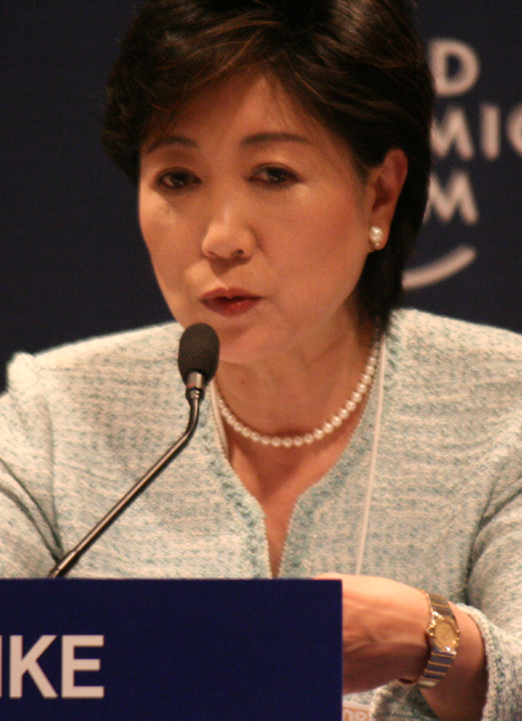

Photos, Top: Margaret Chan; Bottom row: Cristina Fernández de Kirchner, Yuriko Koike, Park Geun-hye, and Oprah Winfrey

Photo Credits:
Margaret Chan: Albouy, Pierre. 2013. World Health Organization, WHO.int. Web. 4 March 2015.
Cristina Fernández de Kirchner: Cristina Fernández de Kirchner 2011-12-10. 2011. Presidency of Argentina, presidencia.gov.ar, licensed under CC BY-SA 2.0 via Wikimedia Commons, commons.wikimedia.org. Web. 4 March 2015.
Yuriko Koike: Yuriko Koike – World Economic Forum on the Middle East 2008. 2008. World Economic Forum, licensed under CC BY 3.0 br via Wikimedia Commons, commons.wikimedia.org. Web. 8 August 2016.
Park Geun-hye: KOCIS Korea President Park MMCA 02 (10863073124). 2013. Korean Culture and Information Service, Korea.net, licensed under CC BY-SA 2.0 via Wikimedia Commons, commons.wikimedia.org. Web. 4 March 2015.
Oprah Winfrey: Hernandez, Greg. Oprah Winfrey at 2011 TCA. 2011. Licensed under CC BY 2.0 via Wikimedia Commons, commons.wikimedia.org. Web. 4 March 2015.

