Improving the lives of women and girls
through programs leading to social
and economic empowerment.

Soroptimist International of the Americas

Generation X: Notable Events That Shaped Their Perspectives

1970 Time and Newsweek Magazines run cover stories on the women’s movement; Japan becomes the 4th nation to put a satellite in orbit; Beatles break up.
1971 VCRs introduced
1972 Winter Olympics held outside of Europe and North America for the first time, in Sapporo, Japan; Watergate scandal begins.
1973 U.S. pulls out of Vietnam; Salvador Allende, President of Chile, overthrown.
1974 Isabel Martinez de Peron succeeds her husband as president of Argentina; U.S. President Nixon resigns.
1975 First UN Women’s conference held in Mexico City; Microsoft founded; Saturday Night Live premiers.
1976 North and South Vietnam join to form the Socialist Republic of Vietnam.
1977 Japan’s Chako Higuchi wins LPGA Championship, making her the first Asian-born player to win a major championship for either men or women; Asian Women’s Association founded in Japan ; Star Wars movie released.
1978 More women than men enter college in the U.S.; Amazon Cooperation Treaty signed by Bolivia, Brazil, Colombia, Ecuador, Guyana, Peru, Suriname, and Venezuela; First test-tube baby born.
1979 Margaret Thatcher is elected Europe’s first female prime minister; Mother Teresa awarded the Nobel Peace Prize; Sony introduces the walkman.
1980 Jeanne Sauvé becomes first woman Speaker of the House of Commons in Canada; Iceland elects Vigdis Finnbogadottir as president (first women anywhere to be elected head of state); John Lennon assassinated; Rubik's Cube and Pac-Man are popular.
1981 Canadian Constitution amended to guarantee equality for women; Gro Harlem Brundtland elected Prime Minister of Norway; New plague identified as AIDS; Personal computers (PC) introduced by IBM.
1982 First International Day of Peace declared by the UN; Bertha Wilson appointed first woman Supreme Court Justice in Canada E.T. movie and Michael Jackson’s Thriller album released.
1983 Sally Ride becomes the first American woman in space; Soviets shoot down a Korean airliner; Democratic elections held in Argentina after 7 years of military rule; Tokyo Disneyland opens.
1984 Benedita da Silva is the first black woman elected to Brazilian Congress; Pope John Paul II visited South Korea, canonized over 100 martyrs executed during Joseon Dynasty; Indira Gandhi, India's female Prime Minister, killed by two bodyguards.
1985 Japan launches Sakigake space probe to Halley’s comet; First Internet domain name is registered; Hole in the ozone layer discovered; Musicians record charity single "We Are the World."
1986 Corazon Aquino becomes president of the Philippines; Space Shuttle Challenger explodes; Chernobyl nuclear disaster; Ferdinand Marcos flees the Philippines; Halley's comet passes by.
Sources and references:
Friedman, D., Mangiafico, L., Blake, J., Wintz, L. (1996). Soroptimist International of the Americas: Serving Communities for 75 Years. Soroptimist International of the Americas.
Rosenberg, J. (n.d). Timeline of the 20th Century. Retrieved from http://history1900s.about.com/od/timelines/tp/1970timeline.htm; and http://history1900s.about.com/od/timelines/tp/1980timeline.htm.

Generation X: Notable Soroptimist Events

1970 Soroptimist has 883 clubs and 24,100 members.
1971 Soroptimist celebrates its 50th Anniversary; the first club in Caracas Venezuela is formed.
1972 Training Awards Program (TAP) is established; later known as the Women’s Opportunity Awards; now known as the Live Your Dream Awards.
1973 First club is chartered in San Salvador, El Salvador.
1976 First club is chartered in Guatemala City, Guatemala; Japan Region is established; Southwestern Region divides into three new regions—Founder, Sierra Nevada; and Sierra Pacific.
1977 First club is chartered in Managua, Nicaragua.
1978 First clubs in San Juan, Puerto Rico, and Agana, Guam, are chartered; the Pacific Region divides into three new regions: Camino Real, Desert Coast, and Golden West
1980 First clubs are charted in Asuncion, Paraguay, and Saipan, Northern Marianas; first “Youth Seminar” is held with participants from Brazil, Canada, Japan and the U.S.; Soroptimist has 1,126 clubs and 33,500 members.
1981 The first club is chartered in Cochabamba, Bolivia; Sandra Day O’Conner, a former Soroptimist member, is the first woman to be appointed to the U.S. Supreme Court.
1983 Philippines Region is established.
1985 The first federation mission statement is adopted, which emphasized Soroptimist was a forward-looking, dynamic, expanding, world-wide diversified service organization.
1986 The Caribbean, Korea, and Mexico Regions are established; Japan Regions divide into five regions.

Sources and references:
Friedman, D., Mangiafico, L., Blake, J., Wintz, L. (1996). Soroptimist International of the Americas: Serving Communities for 75 Years. Soroptimist International of the Americas.

Prominent Generation Xers

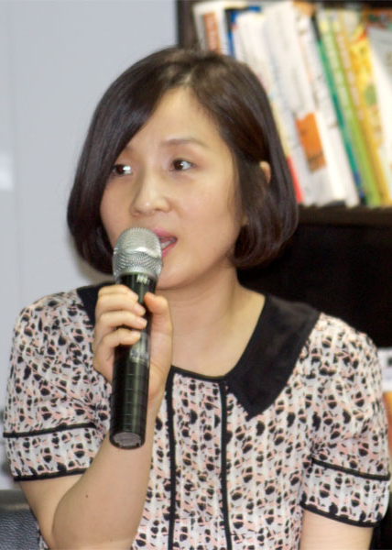
- Ayumi Hamasaki, Japanese recording artist and celebrity
- Jung Ihyun, Korean novelist
- Karylle Tatlonghari, Filipina singer/celebrity
- Chen Shih-hsin, first Taiwanese athlete to win gold at Olympics
- Ruby Lin, Taiwanese actress/producer/director
- Paola Rojas, Mexico City television news anchor
- Celine Dion, Canadian singer
- Kirsten Gillibrand, U.S .Senator from New York
- Rachel Maddow, American television host/political commentator
- Jennifer Lopez, American entertainer

Photos, Top: Jung Ihyun; Bottom row: Karylle Tatlonghari; Ruby Lin; Paola Rojas; and Kirsten Gillibrand

Photo Credits:
Jung Ihyun: CCmontgom. JungIHyun. Licensed under CC BY-SA 3.0 via Wikimedia Commons, commons.wikimedia.org. Web. 11 March 2015.
Karylle Tatlonghari: Miranda, Mickey. Karylle by Mickey Miranda, June 2011.2011. Licensed under CC BY 2.0 via Wikimedia Commons, commons.wikimedia.org. Web. 12 March 2015.
Ruby Lin: Tinakr. Ruby Lin 127 in Beijing. Licensed under CC BY-SA 3.0 via Wikimedia Commons, commons.wikimedia.org. Web. 12 March 2015.
Paola Rojas: Redpaolux. Paola Rojas. Licensed under CC BY-SA 3.0 via Wikimedia Commons, commons.wikimedia.org. Web. 12 March 2015.
Kirsten Gillibrand: Gillibrand 2010. SenatorGillibrandpic. Senator Gillibrand's official 2010 campaign Flickr account - Flickr. Licensed under CC BY-SA 2.0 via Wikimedia Commons, commons.wikimedia.org. Web. 12 March 2015.

