Improving the lives of women and girls
through programs leading to social
and economic empowerment.

Soroptimist International of the Americas

Millennials: Notable Events That Shaped Their Perspectives

1987 New constitution (still in effect today) of the Philippines enacted; Sixth Republic (present-day) government in South Korea established; DNA first used to convict criminals.
1988 Seikan Tunnel connects Japanese islands of Honshu and Hokkaido by rail, making it the longest and deepest in the world; Winter Olympics held in Calgary, Alberta, Canada; First World AIDS Day held.
1989 Japan’s prime minister appoints two women to the Cabinet—a record number; Tiananmen Square protests; Brazil’s first free presidential election in 29 years; Berlin Wall falls; World Wide Web invented.
1990 Elected in 1988, Pakistan’s Prime Minister Benazir Bhutto (first female prime minister of Pakistan) becomes first modern head-of-state to give birth to a child while in office; Presidents of Bolivia, Colombia, Peru, and the U.S. hold a summit and pledge to cooperate in fight against international drug trafficking; Premier of North Korea and president of South Korea meet in the highest level contact between the two countries in 45 years; Violetta Barrios de Chamorro elected president of Nicaragua; Nelson Mandela freed; First known web page written.
1991 Argentina, Brazil, Uruguay, and Paraguay sign Treaty of Asunción creating South Common Market (Mercosur); Aung San Suu Kyi awarded Nobel Peace Prize; South Africa repeals apartheid laws.
1992 Japanese mountain-climber Junko Tabei climbs Puncak Jaya, first woman to complete the Seven Summits (the highest mountain on each continent); Japan issues apology for forcing Korean women into sexual slavery as “comfort women” during WWII; Official end of the Cold War.
1993 Kim Campbell becomes prime minister of Canada; Use of the internet grows exponentially.
1994 Brazil wins FIFA World Cup; Palau gains full sovereignty; Nelson Mandela elected president of South Africa.
1995 4th UN World Conference for Women held in Beijing, resulting in the Beijing Declaration & Platform for Action; Sarin gas attack in Tokyo subway.
1996 Taiwan holds first direct presidential election; Grammys award Album of the Year to Canadian singer Alanis Morissette; First World Cup in Asia is also first World Cup with two co-host countries, Japan and Taiwan; Scientists clone sheep.
1997 Harry Potter and the Philosopher’s Stone published; Japan begins selling Toyota Prius, first hybrid car in full production; Hong Kong returned to China; Princess Diana dies in car crash.
1998 Winter Olympics held in Nagano, Japan.
1999 Beverly McLachlin becomes the first woman to be a Chief Justice of the Canadian Supreme Court; Euro introduced as the new European currency; Fear of Y2K bug; Panama Canal returns to Panama.
2000 First resident crew arrives at International Space Station, beginning still-uninterrupted human presence in space.
2001 UN designated International Year of Volunteers; Birth of Japan's new princess reignites debate over male-only succession law.
2002 Introduction of women’s bobsleigh to the Winter Olympics.
2003 Human Genome Project completed.
2004 Approximately 2 million Taiwanese participate in the 228 Hand-in-Hand Rally forming a 500-kilometer human chain; Brazil launches first successful rocket into space; Taipei 101, the tallest skyscraper at its time, opens.
2005 4th Summit of the Americas held at Mar del Plata, Argentina.
Sources and references:
Friedman, D., Mangiafico, L., Blake, J., Wintz, L. (1996). Soroptimist International of the Americas: Serving Communities for 75 Years. Soroptimist International of the Americas.
Rosenberg, J. (n.d). Timeline of the 20th Century. Retrieved from http://history1900s.about.com/od/timelines/tp/1980timeline.htm; http://history1900s.about.com/od/timelines/tp/1990timeline.htm

Millennials: Notable Soroptimist Events

1988 Disaster Relief Fund established.
1990 At end of the 1990 club year, Soroptimist has 1,453 clubs and 49,602 members.
1992 First club in Taipei, Taiwan, chartered.
1994 Bella Abzug speaks at the SIA 33rd Biennial Convention in Cincinnati, OH.
1995 Taiwan Region established.
1996 SI federations celebrate the organization’s 75th anniversary.
1997 Caribbean Region is renamed Central America.
2000 At end of the 2000 club year, Soroptimist has 1,514 clubs and 46,768 members.
2002 Mexico Region and Central America Regions combined and renamed Mexico-Centroamerica Region.
Sources and references:
Friedman, D., Mangiafico, L., Blake, J., Wintz, L. (1996). Soroptimist International of the Americas: Serving Communities for 75 Years. Soroptimist International of the Americas.

Prominent Millennials

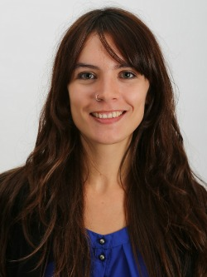
- Camila Vallejo, Chilean representative in House of Deputies, former Chilean student leader
- Julia Bacha, Brazilian documentary filmmaker
- Shahrzad Rafati, Iranian-Canadian CEO and founder of BroadbandTV
- Risa Wataya, Japanese novelist
- Yeonmi Park, Korean human rights activist
- Malala Yousafzai, Pakistani activist for girls’ education
- Drue Kataoka, Japanese-American artist
- Michelle Bumgarner, Filipina racecar driver
- Rachel Haot, American entrepreneur & chief digital officer/deputy secretary of technology for New York State
- Ellora Israni & Ayna Agarwal, American cofounders of She++, a social enterprise empowering women in technology

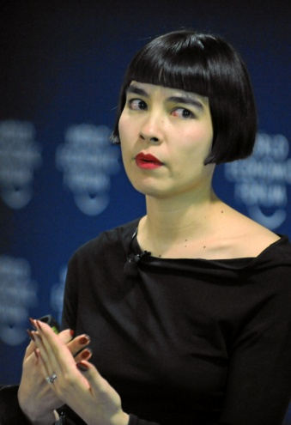

Photos, Top: Camila Vallejo; Bottom row: Shahrzad Rafati, Yeonmi Park, Malala Yousafzai, and Drue Kataoka

Photo Credits:
Camila Vallejo: Biblioteca del Congreso Nacional. Camila Vallejo Dowling BCN. 2014. Chile, historiapolitica.bcn.cl, Licensed under CC BY-SA 3.0 via Wikimedia Commons, commons.wikimedia.org. Web. 18 March 2015.
Shahrzad Rafati: Holst, Peter. Shahrzad Rafati—CEO and Founder of BroadbandTV. Licensed under CC BY-SA 1.0 via Wikimedia Commons, commons.wikimedia.org. Web. 18 March 2015.
Yeonmi Park: Juddweiss. Yeonmi Park—Atlas Network Liberty Forum. 2014. Licensed under CC BY-SA 4.0 via Wikimedia Commons, commons.wikimedia.org. Web. 20 March 2015.
Malala Yousafzai: Southbank Centre. Malala Yousafzai. 2014. https://www.flickr.com/photos/southbankcentre/, Licensed under CC BY 2.0 via Wikimedia Commons, commons.wikimedia.org. Web. 20 March 2015.
Drue Kataoka: Drue Kataoka—World Economic Forum Annual Meeting 2011. 2011. World Economic Forum, Licensed under CC BY-SA 2.0 via Wikimedia Commons, commons.wikimedia.org. Web. 18 March 2015.

